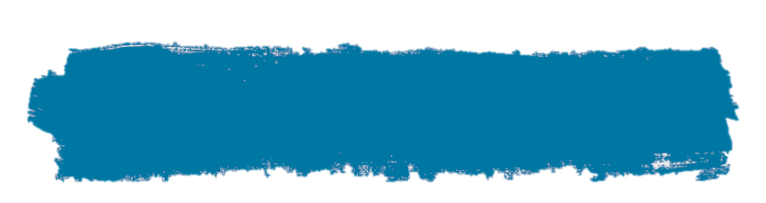

Geography – Map Skills

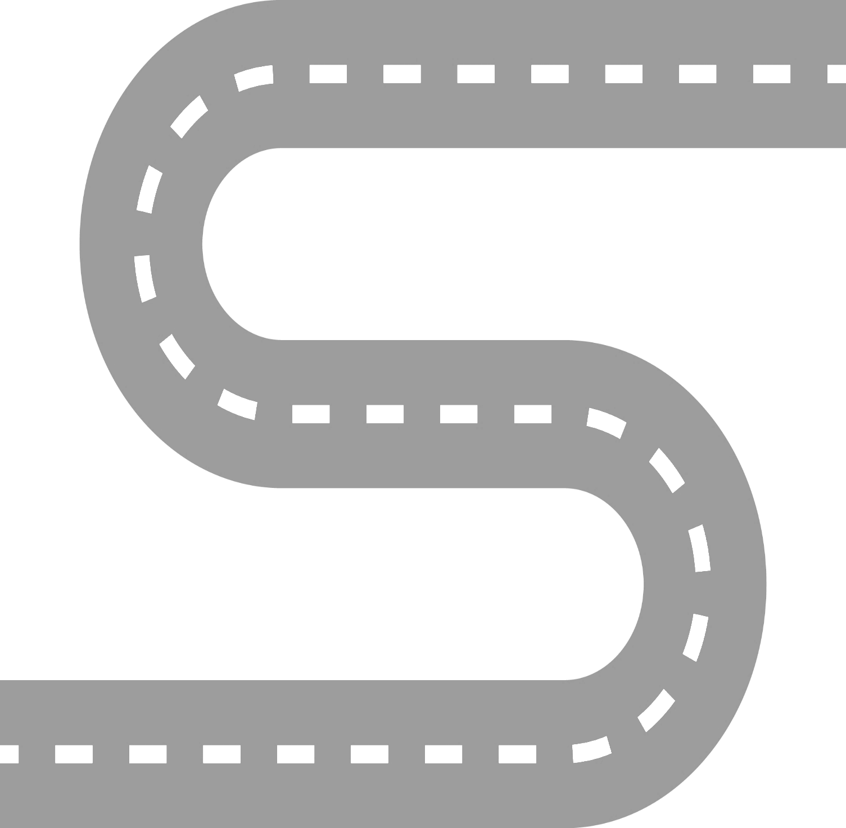

**EYFS**

* I can draw information from a simple map.

.

**YEAR 1**

* I can use compass directions (north, south, east and west) and locational language (e.g. near and far) to describe the location of features and routes on a map.
* I can use maps, globes and atlases to help me.
* I can understand and use basic symbols on a map.

**YEAR 3**

* I can use maps, atlases, globes and digital/computer mapping to locate countries and describe features
* I can use the four points of a compass, letter and number grid references, and symbols and key to follow and give directions, communicate knowledge of the United Kingdom and the wider world.

**YEAR 6**

* I can use eight compass points and six-figure grid reference to make a simple scale drawing.

**YEAR 5**

* I know and use the eight points of a compass, four-figure grid references, symbols and a key (that uses standard Ordnance Survey symbols) to communicate knowledge of the United Kingdom and the world.

**YEAR 4**

* I can use the eight points of a compass, four-figure grid references, symbols and key to navigate around a given route.

**YEAR 2**

* I can use world maps, atlases and globes to identify UK, continents and oceans.
* I can use simple compass directions (N, E, S, W) and locational and directional language.
* I can understand basic symbols on a map.