



**EYFS**

* Set and work towards simple goals, being able to wait for what they want.

My PSHE Learning Journey –

Transition and Identity

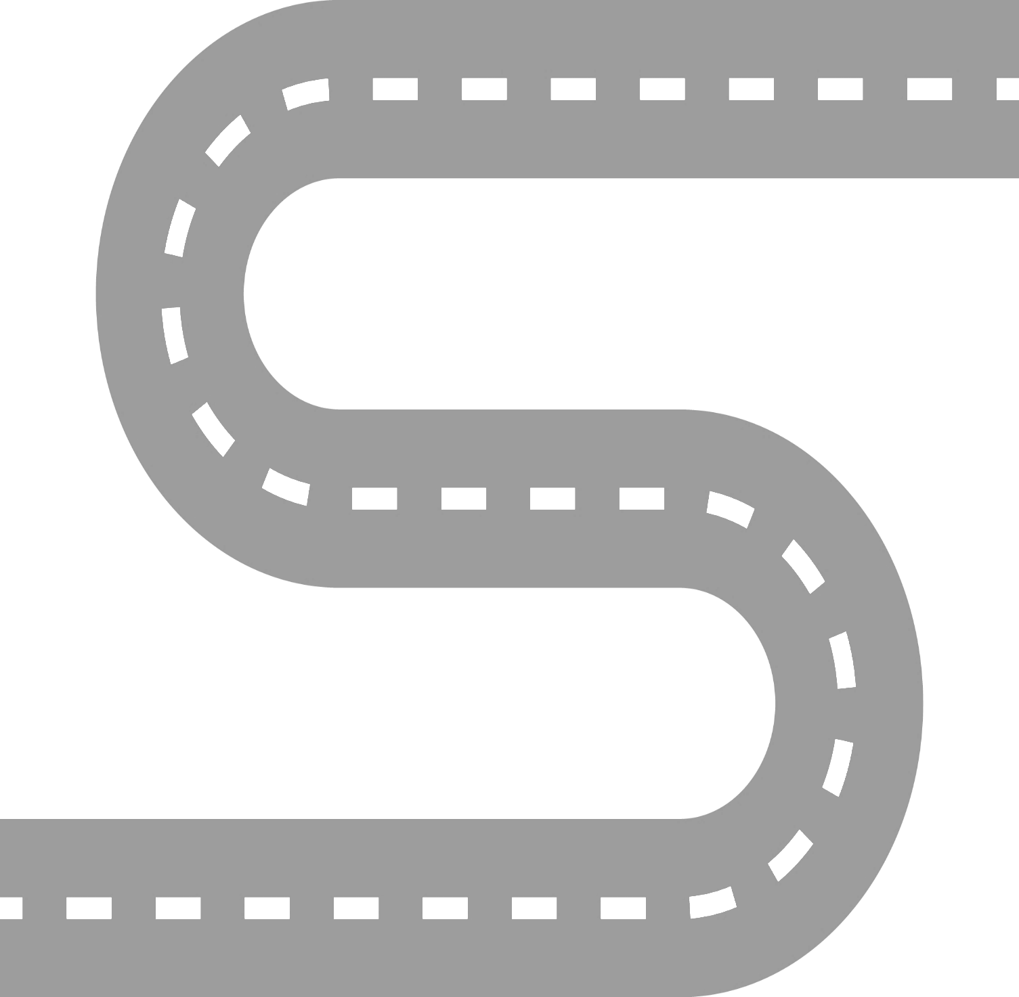

**YEAR 6 – Identity**

* To know that identity is the way we see ourselves and also how other people see us.

**YEAR 5**

* To know the skills needed for roles in school.

**YEAR 6**

* To know that a big change can bring opportunities but also worries.

**YEAR 4**

* To know that setting goals can help us to achieve what we want.

**YEAR 3**

* To know that change often brings about more opportunities and responsibilities.

**YEAR 2**

* To know that change is part of life..

**YEAR 1**

* To know that changes can be both positive and negative.