



**YEAR 1**

* To know some of the ways children may receive money.
* To know it is wrong to steal money.
* To know that banks are places we can store our money.

**EYFS**

* To be able to wait for what they want and control their immediate impulses.

My PSHE Learning Journey –

Economic Wellbeing

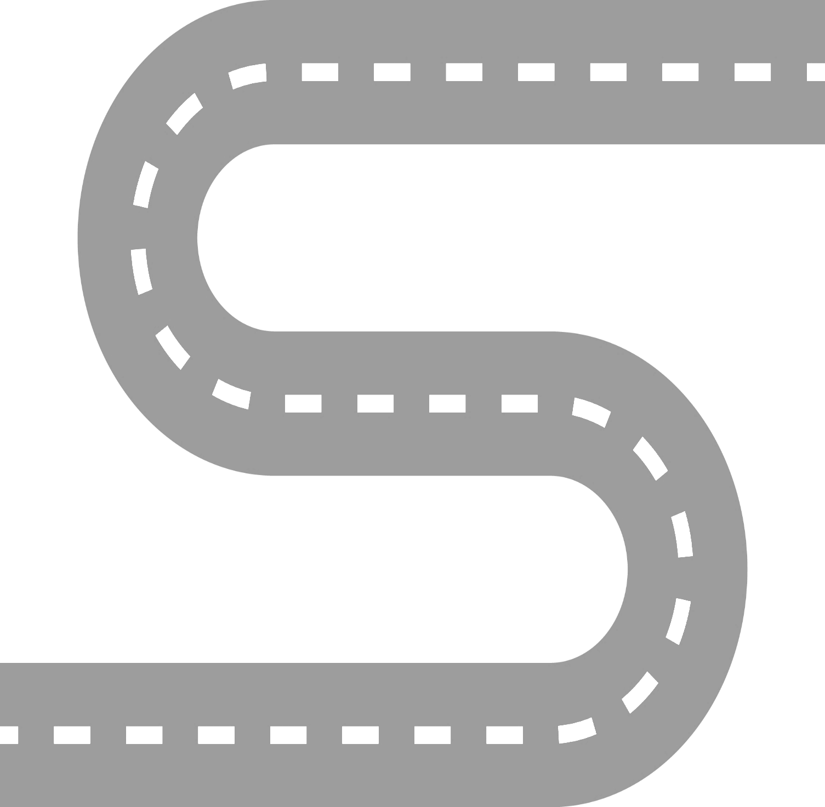

**YEAR 6**

* To understand that there are certain rules to follow to keep money safe in bank accounts.
* To know that gambling is a risk where money, or something else, is swapped in the hope of winning something better or more money.
* To understand that different jobs have different routes into them.
* To understand that people change jobs for a number of reasons.

**YEAR 5**

* To know that when money is borrowed it needs to be paid back, usually with interest.
* To know that it is important to prioritise spending.
* To know that the income is the amount of money received and expenditure is the amount of money spent.
* To know some ways that people lose money.

**YEAR 4**

* To know that money can be lost in a variety of ways.
* To understand the importance of tracking money.
* To know that people will have more than one job or career in their lifetimes.

**YEAR 3**

* To know that there are different ways to pay for things.
* To know that budgeting money is important.
* To know that there are a range of jobs available.

**YEAR 2**

* To know some of the ways in which adults get money.
* To know the difference between ‘need’ and ‘want’.