



**YEAR 1**

* To know the rules in school.
* To know how to look after a pet.
* To know that voting is a fair way to make a decision..

**EYFS**

* To know the reasons for rules.

My PSHE Learning Journey –

Citizenship

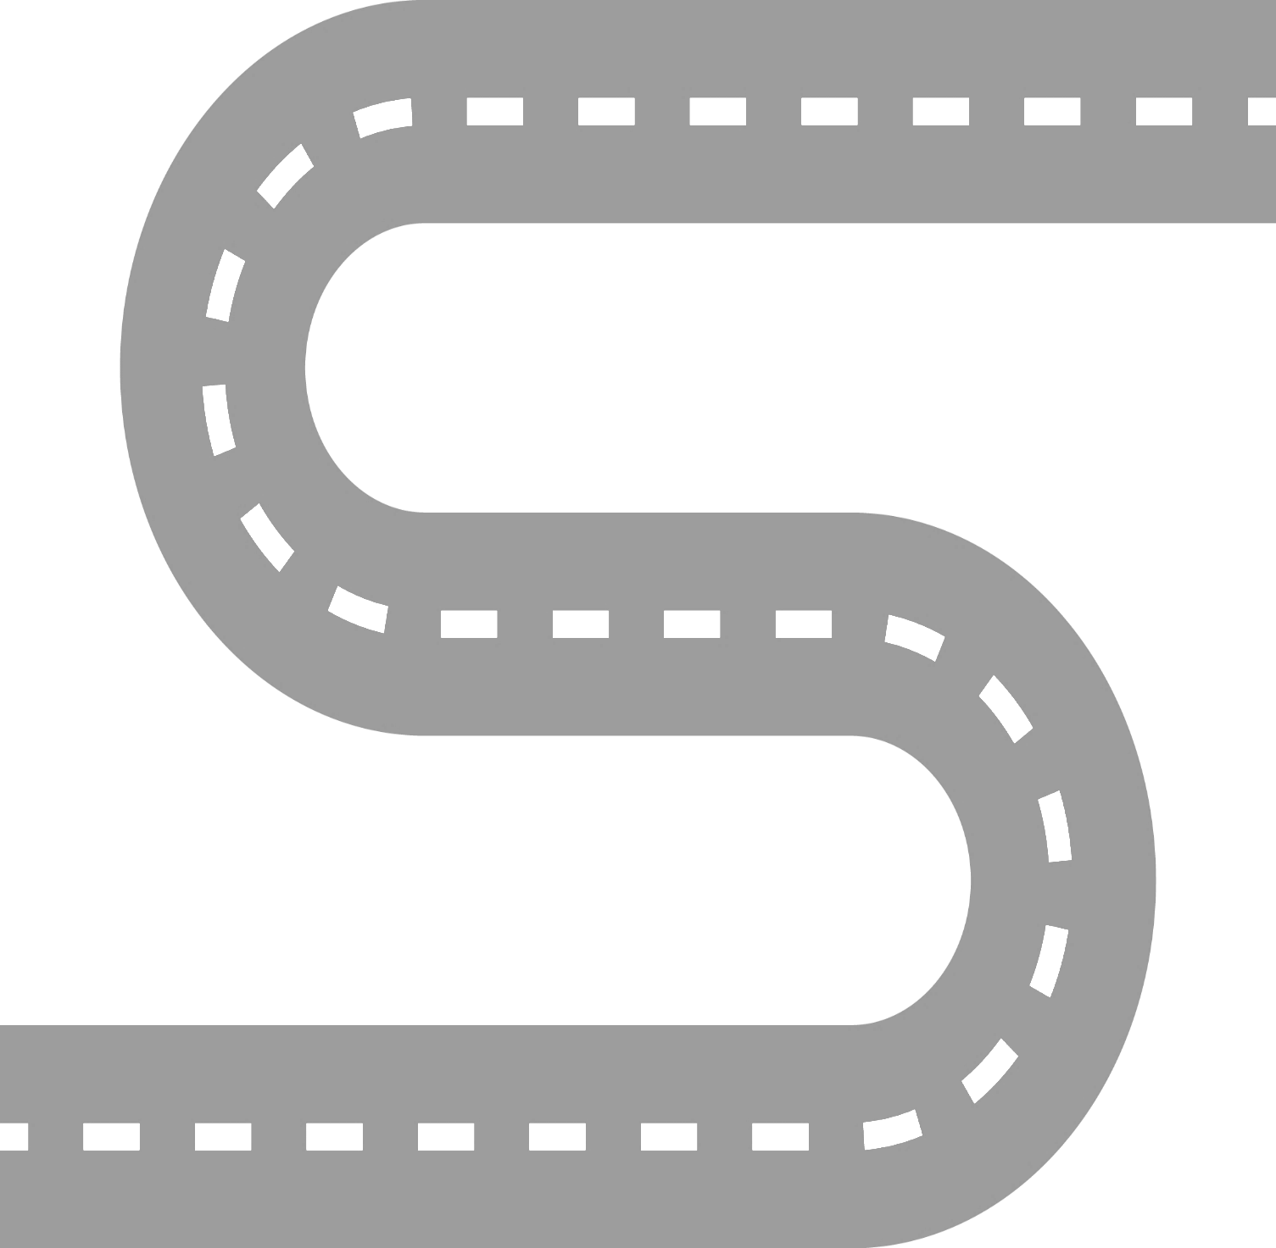

**YEAR 6**

* To know that education is an important human right.
* To know that our food choices can affect the environment.
* To know that the prime minister appoints “ministers” who have responsibility for different areas such as healthcare and education.
* To know that prejudice is making assumptions about someone based on certain information.
* To know that discrimination is treating someone differently because of certain factors.

**YEAR 5**

* To know what happens when someone breaks the law.
* To know that parliament is made up of the House of Commons, the house of lords and the Monarch.
* To know that parliament is where MPs debate issues, propose laws and challenge the governments’ work.

**YEAR 4**

* To know that human rights are specific rights that apply to all people.
* To know some of the people who protect our human rights such as police, judges and politicians.
* To know that reusing items is of benefit to the environment.
* To know that there are a number of groups which make up the local community.

**YEAR 3**

* To know that recycling can have a positive impact on the environment.
* To know that elections are held where adults can vote for local councilors.
* To know some of the consequences of breaking rules.
* To know the role of charities in the community.

**YEAR 2**

* To know that some rules are made to be followed by everyone and are known as ‘laws’.
* To know how democracy works in school through the school council.
* To know how to help look after the school environment.