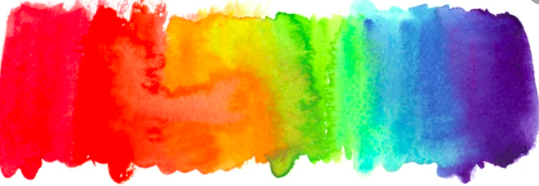



**YEAR 1**

* I know how to clean my hands properly.
* I know some foods can cause an allergic reaction in some people.
* I know that strengths are things we are good at.

My PSHE Learning Journey –

Health and well being

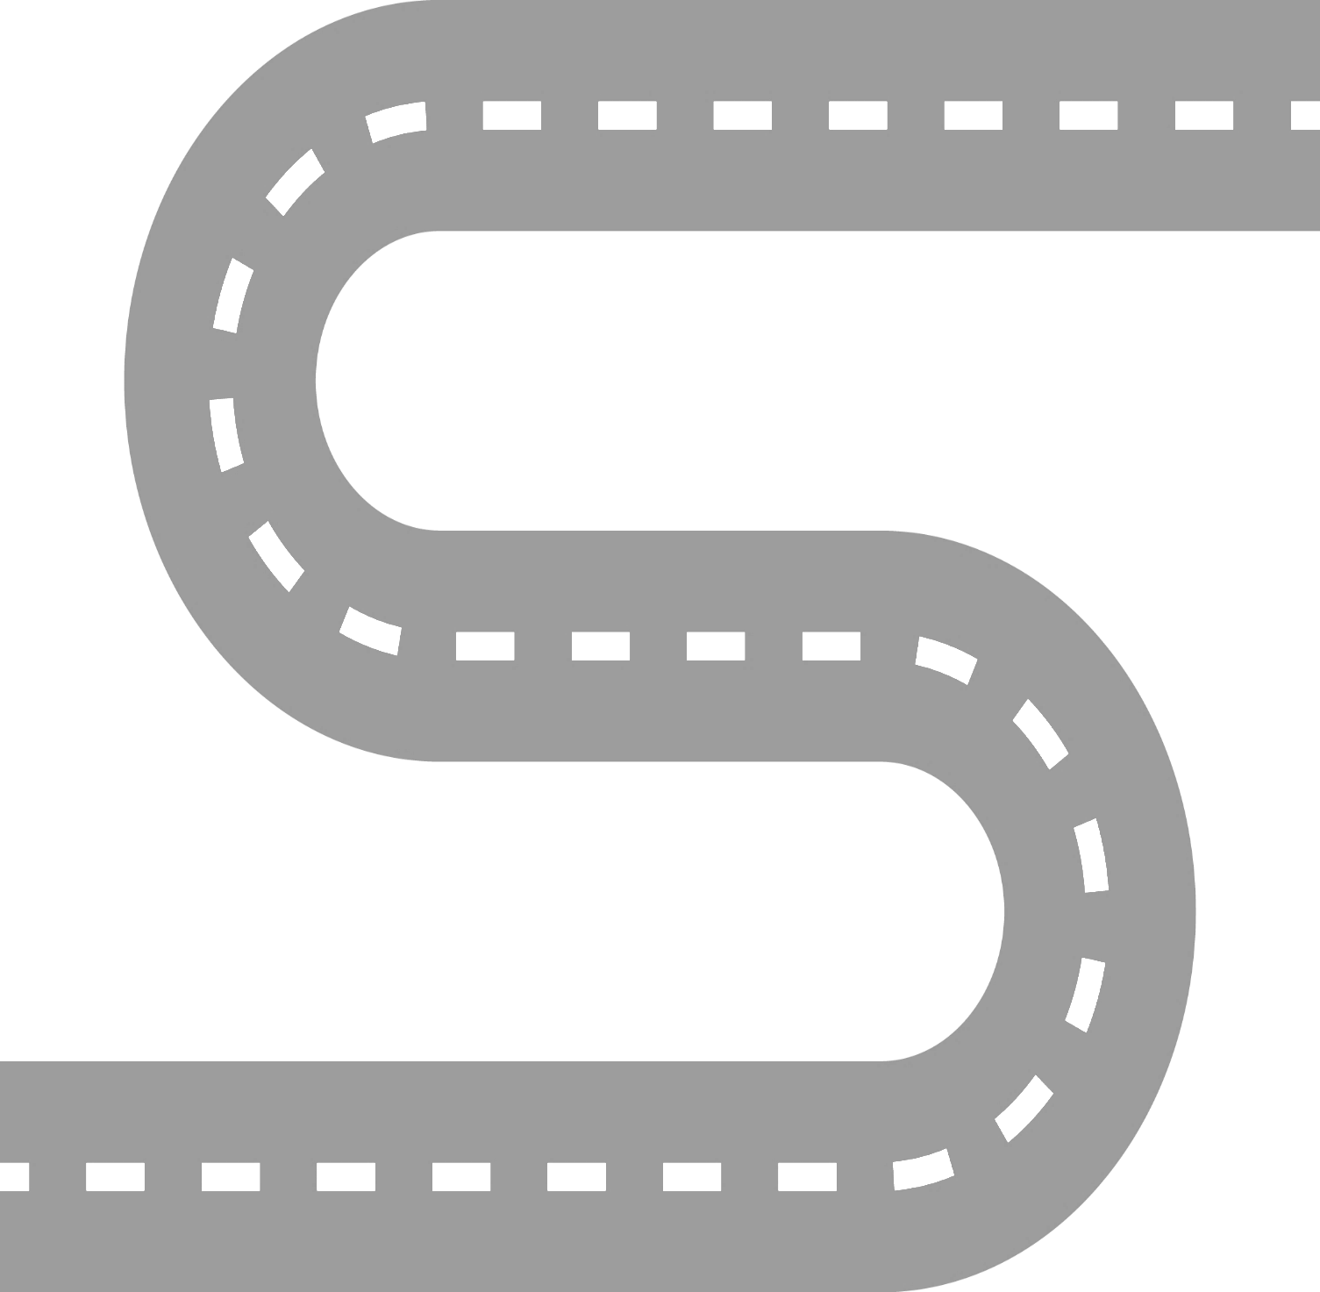

**EYFS**

* Manage their own basic hygiene and personal needs, including dressing, going to the toilet and understanding the importance of healthy food choices.

Health and prevention

Physical health and well being

Mental well being

**YEAR 6**

* I know that vaccinations can give us protection against disease.
* I know that a number of factors contribute to my physical health (diet, exercise, rest/relaxation, dental health).
* I know the effects technology can have on mental health.

**YEAR 5**

* I understand the risks of sun exposure.
* I know that relaxation stretches can help us to relax and de-stress.
* I know what can cause stress.

**YEAR 4**

* I know key facts about dental health.
* I know that visualization means creating an image in our heads.
* I know that mental health refers to our emotional wellbeing, rather than physical.

**YEAR 3**

* I know and understand ways to prevent tooth decay.
* I know and understand the positive impact relaxation can have on the body.
* I know and understand what being lonely means and that it is not the same as being alone.

**YEAR 2**

* I know that food and drinks with lots of sugar are bad for our teeth.
* I know the importance of exercise to stay healthy.
* I know breathing techniques can be a useful strategy to relax.
* I know that a growth mindset means being positive about challenges.