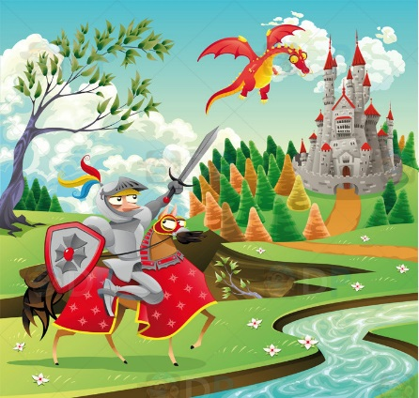

Dear Parents,
Welcome to Year 1. I hope you have all had a relaxing summer holiday. The children have been very excited to be back in school and have been busy getting to know the rules and routines of the year 1 classroom.
School Day
8.50am – Enter school through Year 1 porch door and register
9am – 9.20am – Phonics
9.20am – Literacy/Numeracy lessons – activities
10.30am – Play time – snacks from home.
10.45am – Numeracy/Literacy lessons - activities
11.45am – lunch
12.45pm – Register and afternoon activities (D&T, Art, RE, History, Geography, PE, Computing, PSHE, Music)
2pm – last play – fruit snack from school
2.15pm – afternoon activities (D&T, Art, RE, History, Geography, PE, Computing, PSHE, Music)
3.10pm - Home time
Reading
Your child has received their new reading record and a reading book today. Over the next few weeks we will assess their reading levels and change books accordingly. In Year 1 the children place their diaries and books into baskets every morning. An adult at some point during the day will check diaries and change books where necessary. Please can you comment when you read with your child and clearly state when the book has been finished. I will aim to hear your child read once a week. If anyone would like to come in and help to hear a group of readers that would be very much appreciated, just pop in and have a chat with me to sort out a convenient day to do this.
Communication
If you need to discuss anything about your child, there will be an adult available before and after school, however messages can be sent via diaries. If you have an important message in the diary please encourage your child to pass the diaries to an adult as we don’t always look at them until the afternoon.
Snacks
The children can bring a healthy snack for first break. School provides fruit at last break.
Forest School
Forest School will be every other Tuesday with Mrs Morgan. (Timetables are stuck in front cover of reading diaries). Due to the limited space in the cloakroom we have decided all children can come to school wearing their forest school clothes but will need spare shoes in a clearly named bag.

PE
PE will be on a Wednesday and a Friday. All PE kits can stay in school over the half term, however if they do get dirty we will send them home earlier! Children can choose trainers or pumps, however trainers are more waterproof outside.
Money and slips
If you send any money or slips in to school place them in the school diaries or ask your child to hand to a Year 1 adult. We will then send it to the school office. Please ensure all envelopes with money inside are labelled clearly.
Topic
Our topic this half term is ‘Medieval Magic.’ – We will cover this topic in all areas of the curriculum. If your child has any books or artefacts related to any of our topics, please feel free to send them in. It will be your child’s responsibility to look after anything brought into school.
Twitter Page
We have a class twitter page. To follow it please request to follow WeaverClass1 @Class1Dmorris
For security reasons I will only accept your request if I know you are a parent of a child in Class 1 so if you could let me know who you are and who your child is in a private message that would be great.

I hope this helps clarify some of the Year 1 routines, if you have any queries or questions please do not hesitate to ask me.
Thank you for your support.

D Morris

