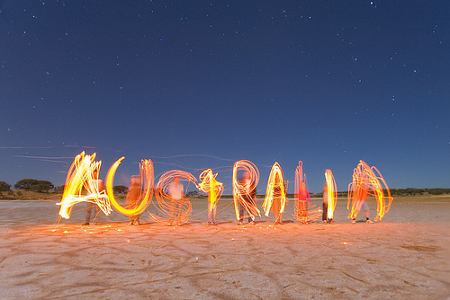

**Spring Term 2022**

[](https://www.google.co.uk/url?sa=i&rct=j&q=&esrc=s&source=images&cd=&ved=0ahUKEwiu6ZLhzY7KAhXJvRoKHTSCC9UQjRwIBw&url=http://www.building-information.co.uk/page/2/&psig=AFQjCNH8S3EBUsnXWxO3en3-ezPVDB-OoQ&ust=1451943648897242)

**Australia**

*History and Geography:*  
Locating 7 continents and 5 oceans.

Looking at a map of Australia—using maps and globe to locate different states and places;

Recognise the different physical and human features of Australia.  
Exploring the differences between the different states ie Queensland is more tropical than New South Wales ;  
Looking at the areas of nature that make Australia so special—the Rainforest and the Great Barrier reef as a focus (using the film Finding Nemo and Steve Irwin—Crocodile Hunter as a stimulus for work on the marine/ wild life in these places.  
Looking at the work of the late Steve Irwin and his wife at the Australia Zoo—Exploring information from the website and looking at conservation projects there.

Map work – School grounds

*Maths:*

~ Calculate mathematical statements for multiplication and division within multiplication tables and write them using the multiplication (x), division (÷), and equals (=) sign

~ Recognise and use symbols of pounds and pence, combine to make a particular value

~ Find different combinations of coins that equal the same amounts of money

~ Solve simple problems involving addition and subtraction of money of the same unit including giving change

~ Identify and describe the properties of 3D shapes, including the number of edges, vertices and faces.

~ Identify the lines of symmetry

~ Identify 2D shapes on the surface of 3S shapes (for example, a circle on a cylinder).

Art

To use a map as a stimulus.

To learn and apply steps of the felt making process

To create a map using felt.

Drawing different animals in the style of aboriginal art; Designing own aboriginal art

DT

Select fabrics to make a pouch

To learn a running stitch

Decorate the pouch using a running stich and gluing items on.

Design and make your own boomerangs and didgeridoos

To design and make a healthy wrap.

*Music*

The Great Composers  
Rhythm stick games  
Looking at the didgeridoo—listening to some didgeridoo music and designing their own ‘didgeridoos’

*ICT*:

Taking better photos

Learning how to research

*PE:*

Gymastics

Dance

*RE*

Jesus the storyteller

Easter

*Science:*

Exploring different habitats of animals native to Australia;  
Looking at the Great Barrier Reef and all the different types of marine life that live there  
Exploring the weather of Australia and the different temperatures at different times of the year compared to Britain

Materials

Uses of everyday materials and their properties

~ Revise the names of common materials and understand there are many different uses for materials

~ To understand that different materials can be used to make the same things

~ To find out which materials are waterproof

~ To understand which materials are natural and which are manufactured

~ To understand and investigate which materials are the most absorbent

*English:*

~ To develop story writing through drama, planning, talking and editing. To use dreamtime stories to write and plan our own stories.

* Rainbow Serpent Dreamtime story
* Tiddalik
* How the birds got their colours
* Koala and his stumpy tail

Comprehension focus

~ staying safe at the beach and in the sun – slip slap slop

~ Australian animals and the Great Barrier Reef

~ Dreamtime stories

~ To know the 4 different types of sentences, command, explanation, statement, question

~ To know and give examples of nouns, verbs, adjectives and adverbs

~ To continue to develop and use capital letters, full stops and question marks.